South Ribble Borough Council
Application for the review of a premises licence or club premises certificate under the Licensing Act 2003
PLEASE READ THE FOLLOWING INSTRUCTIONS FIRST
Before completing this form please read the guidance notes at the end of the form.
If you are completing this form by hand please write legibly in block capitals. In all cases ensure that your answers are inside the boxes and written in black ink. Use additional sheets if necessary. You may wish to keep a copy of the completed form for your records.
I Christopher Ward — Licensing Manager
(Insert name of applicant) apply for the review of a premises licence under section 51 / apply for the review of a club premises certificate under section 87 of the Licensing Act 2003 for the premises described in Part 1 below (delete as applicable)
Part 1 Premises or club premises details
Postal address of premises or, if none, ordnance survey map reference or description
Best One
Poplar Avenue
Post town  Bamber Bridge |  | Post code  PR5 6JJ
Name of premises licence holder or club holding club premises certificate (if known)
Mr Markandu Lingarasa

Part 2 Applicant details
I am
Please tick v/ yes
l) an individual, body or business which is not a responsible authority (please read guidance note l , and complete (A) or (B) below)
- a responsible authority (please complete (C) below)
- a member of the club to which this application relates
(please complete (A) below)
(A) DETAILS or INDIVIDUAL APPLICANT (fill in as applicable)
Please tick y/ yes
Miss Other title
(for example, Rev)
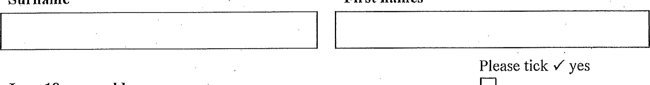First names
Surname
I am 18 years old or over
Current postal address if different from premises address
Post town
Daytime contact telephone number
IC-mail address (optional)
- DETAILS OF OTHER APPLICANT
Name and address
Telephone number (if any)
Frmail address (optional)
- DETAILS OF RESPONSIBLE AUTHORITY APPLICANT
Name and address
South Ribble
Borough Council Licensing
Civic Centre
West Paddock
Leyland
PR25 IDH
Telephone number (if any) 01772 625330
E-mail address (optional)
Licensing@southribble.gov.uk
This application to review relates to the f'ollowing licensing objective(s)
Please tick one or more boxes v/
l) the prevention of crime and disorder 6
2) public safOty prevention of public nuisance
4) the protection of children from harm
Please state the ground(s) for review (please read guidance note 2)
Introduction
Joint Immigration and Licensing Visit - 11/03/2023
At approximately 17:30, a joint visit to the premises took place, by representatives from the Home
Office, authorised to carry out Immigration Enforcement and Chris Ward from the Licensing Authority.
On entry to the premises, upon turning into the store to the counter, it was clear, two males were present behind the counter. All officers were identified to them and an explanation of the reason for the visit was given.
Male one identified himself to immigration officers as Mr Markandu Lingarasa, he was in charge at the premises.
Male two identified himself as
Enquires were made by Immigration Officers regarding—status. After about 5 minutes it had been revealed that he did not have rights to work in the UK.
Whist the immigration officers continued their work in questioning—, a separate interview by Immigration Officers took place with Mr Lingarasa.
Immigration Officers asked Mr Lingarasa if, —was working at the premises.
Mr Lingarasa denied that was working at the premises and stated that he was just a friend who was visiting him.
A third member of staff attended the premises
CCTV
Mr Lingarasa was asked by Immigration officers to provide access to the shop's CCTV system.
Mr Lingarasa stated, "CCTV system not working"
Immigration officers asked, why one of the cameras behind the till had a green light displayed?
Mr Lingarasa stated again, {'no, CCTV isn't working".
Upon inspection of the stock room at the rear of the premises, Immigration officers then found that Mr Lingarasa did in fact have a CCTV system at the rear of the premises in the stock room. The system was fully functional and in operation.
Immigration officers then operated the CCTV system, replayed the recorded footage, which revealed had been working behind the counter before officers attended, and was clearly observed completing sales of alcohol to customers, clearly working at the premises.
The Immigration Officer's notes and statements are attached as Document 1
2nd Immi ration Visit 12th Jul 2023
On 12 ^{th} July 2023, Officers from the immigration service, conducted a second inspection of the premises for illegal workers, following information that had been passed through from the Licensing teams.
2 alleged illegal workers were found in the premises and arrested by immigration officers on the scene.
was spotted walking to the back of the premises and was encountered at the rear of the premises and subsequently arrested as a worker in breach.
who was also considered to be working at the premises as he was spotted in a staff area at the storage room at the back, he revealed he had an outstanding asylum claim with no right to work in the UK. He was subsequently arrested.
The immigration Officers statement can be found attached as Document 2.
Employment of Illegal Workers
In employing these individuals, the Licence Holder committed an offence, the Secretary of State's Guidance takes robust approach to illegal workers in Licensed Premises;
The latest revision of the Section 1 82 Guidance makes numerous references to the employment of illegal workers,
The paragraphs below explain how the employment of illegal workers ties in with the Crime and Disorder Objective and also highlights it as an issue that Licensing Authorities should take very seriously;
9.25
The Immigration Act 2016 made the Secretary of State a responsible authority in respect of premises licensed to sell alcohol or late-night refreshment with effect from 6 April 2017. In effect this conveys the role of responsible authority to Home Office Immigration Enforcement who exercises the powers on the Secretary of State's behalf. When Immigration Enforcement exercises its powers as a responsible authority it will do so in respect of the prevention of crime and disorder licensing objective because it is concerned with the prevention of illegal working or immigration offences more broadly.
11.26
Where the licensing authority is conducting a review on the grounds that the premises have been used for criminal purposes, its role is solely to determine what steps should be taken in connection with the premises licence, for the promotion of the crime prevention objective. It is imponant to recognise that certain criminal activity or associated problems may be taking place or have taken place despite the best efforts of the licence holder and the staff working at the premises and despite full compliance with the conditions attached to the licence. In such circumstances, the licensing authority is still empowered to take any appropriate steps to remedy the problems. The licensing authority's duty is to take steps with a view to the promotion of the licensing objectives and the prevention of illegal working in the interests of the wider community and not those of the individual licence holder.
11.27
There is cenain criminal activity that may arise in connection with licensed premises which should be treated particularly seriously. These are the use of the licensed premises:
for the sale and distribution of drugs controlled under the Misuse of Drugs Act 1971 and the laundering of the proceeds of drugs crime; for the sale and distribution of illegal firearms; for the evasion of copyright in respect of pirated or unlicensed films and music, which does considerable damage to the industries affected; for the illegal purchase and consumption of alcohol by minors which impacts on the health, educational attainment, employment prospects and propensity for crime of young people; for prostitution or the sale of unlawful pornography; by organised groups of paedophi/es to groom children; as the base for the organisation of criminal activity, patticularly by gangs for the organisation of racist activity or the promotion of racist attacks; for employing a person who is disqualified from that work by reason of their immigration status in the UK; for unlawful gambling; and for the sale or storage of smuggled tobacco and alcohol.
11.28
It is envisaged that licensing authorities, the police, the Home Office (Immigration Enforcement) and other law enforcement agencies; which are responsible authorities, will use the review procedures effectively to deter such activities and crime. Where reviews arise and the licensing authority determines that the crime prevention objective is being undermined through the premises being used to futther crimes, it is expected that revocation of the licence — even in the first instance should be seriously considered.
Given the seriousness of being caught employing an illegal worker, you would expect a responsible
licence holder to make sure this doesn't happen again, checks should be made on all employees right to work before they are employed. For this to happen a second time, with two additional illegal workers found working at the premises is unacceptable.
For licensed premises based in South Ribble to be found in this position causes this authority huge concern and I believe the premises have traded irresponsibly and the licence should be revoked.
The following licensing objectives have been undermined at this premises;
The prevention of crime and disorder
With regards to the view of revoking the licence, the following sections of the S182 are relevant;
However, where responsible authorities such as the police or environmental health officers have already issued warnings requiring improvement either orally or in writing — that have failed as part of their own stepped apptoach to address concerns, licensing authorities should not metely repeat that approach and should tal<e this into account when considering what further action is appropriate. Similarly, L^{i}censing authorities may take into account any civil immigration penalties which a licence holder has been requiled to pay for employing an illegal worker.

11.23
Licensing authorities should also note that modifications of conditions and exclusions of licensable activities may be imposed either permanently or for a temporary period of up to three months. Temporary changes or suspension of the licence for up to three months could impact on the business holding the licence financially and would only be expected to be pursued as an appropriate means of promoting the licensing objectives. So, for instance, a licence could be suspended for a weekend as a means of deterring the holder from allowing the problems that gave rise to the review to happen again. However, it will alwaysdbe important that any detrimental •financial impact that may result from a licensing authority's decision is appropriate and proportionate to the promotion of the licensing objectives. But where premises are found to be trading irresponsibly, the licensing authority should not hesitate, where appropriate to do so, to take tough action to tackle the problems at the premises and, where other measures are deemed insufficient, to revoke the licence

Please tick v" yes Have you made an application for review relating to the C) premises before
If yes please state the date of that applicationDay
Month Year
If you have made representations before relating to the premises please state what they were and when you madc them
Please tick v' yes
I have sent copies of this f01•m and enclosures to the responsible authorities and the premises licence holder or club holding the club premises certificate, as appropriate
I understand that if I do not comply with the above requirements my application will be rejected
IT IS AN OFFENCE, LIABLE ON CONVICTION TO A FINE UP TO LEVEL 5 ON THE
STANDARD SCALE, UNDER SECTION 158 OF THE LICENSING ACT 2003 TO MAKE A FALSE STATEMENT IN OR IN CONNECTION WITH THIS APPLICATION
Part 3 Signatures (please read guidance note 4)
Signature of applicant or applicant's solicitor or other duly authorised agent (please read 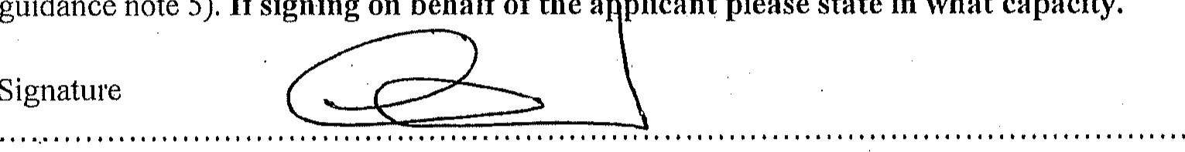guidance note 5). If signing on behalf of the a plicant please state in what capacity.
Date
Contact name (where not previously given) and postal address for correspondence associated with this application (please read guidance note 6)
Post town | Post Code
Telephone number (if any)
If you would prefer us to •correspond with you using an e-mail address your e-mail address (optional)
Notes for Guidance
l . A responsible authority includes the local police, fire and rescue authority and othct• statut01•y bodies which exercise specific functions in the local area.
2. The ground(s) for review must be based on one of the licensing objectives.
- Please list any additional information or details for example dates of problems which are included in the grounds for review if available.
- The application form must be signed.
- An applicant's agent (for example solicitor) may sign the form on their behalf provided that they have actual.authority to do so.
- This is the address which we shall use to correspond with you about this application.

MG Il
WITNESS STATEMENT
Criminal Procedure Rules, r 27.2; Criminal Justice Act 1967, s. 9; Ma istrates' Courts Act 1980 s.5B
Statement of Jack O'Brien URN:
Age if under 18 Over 18 (if over 18 insert 'over 18') Occupation:
Immigration Officer — Home Office
This statement (consisting of 2 pages each signed by me) is true to the best of my knowledge and belief and I make it knowing that, if it is tendered in evidence, I shall be liable to prosecution if I have wilfully stated anything in it which I know to be false, or do not believe to be true.
Signature: J. O'BRIEN .... Date: 18/10/2023
Tick if witness evidence is visually recorded (supply witness details on rear)
1 am an Immigration Officer based at HOME OFFICE IMMIGRATION COMPLIANCE AND
ENFORCEMENT, DALLAS COURT, 1-2 SOUTH LANGWORTHY ROAD, SALFORD, MSO 2GF.
On Wednesday 12th July 2023 1 was the officer in charge on duty as part of an enforcement team that visited Best One Convenience Store. Officers present on the visit were myself (10 0'BRIEN), 10 ELLIS, 10 SAMUELS, 10 HUNT, 10 TAYLOR, 10 DUKE.
The visit was conducted following intel received from Lancashire licencing team after during a previous visit they had encountered a Sri Lankan male born working at the premises. Following later checks conducted on Home Office systems it was revealed he had been working in breach of his visa conditions.
Officers arrived at the premises at approx. 16:50hrs under a 17(2) warrant.
Best One is a reasonably large convenience store with several aisles going across the shop and a large storage area in the back. There were several customers waiting to be served when officerds entered. Officers allowed staff to carry on working whilst checks were being conducted.
As officers entered, the target of the visit, was spotted walking to the back of the premises and was encountered at the rear of the premises by 10 Ellis and subsequently arrested as a worker in breach. He was taken to a cell van parked at the back of the premises where an illegal working interview was conducted. He was eventually taken to police custody as he was liable to be removed from the UK.
()ther checks were conducted by 10 Duke and 10 Samuals on three other males considered to be working at the store, as they they shown various adverse reactions to the officer's presence which led them to believe they were also working illegally. Checks conducted led to two staff being cleared however a check on another male, who was considered to be working at the premises as he was spotted in a staff area at the storage room at the back, revealed he had an outstanding asylum claim with no right to work in the UK. He was subsequently arrested by SAMUELS and an illegal working interview was conducted where he was later walked offthe premises.
An illegal working interview was also conducted with the owner, Markandu Lingarasa, by 10 Duke in relation to the two males found illegally working at the premises. Following this he was served an illegal working civil penalty notice.
The team were then stood down and left the premises at approx. 18:15 hrs.
Signature:Signature witnessed by:
03/2015 MG I l
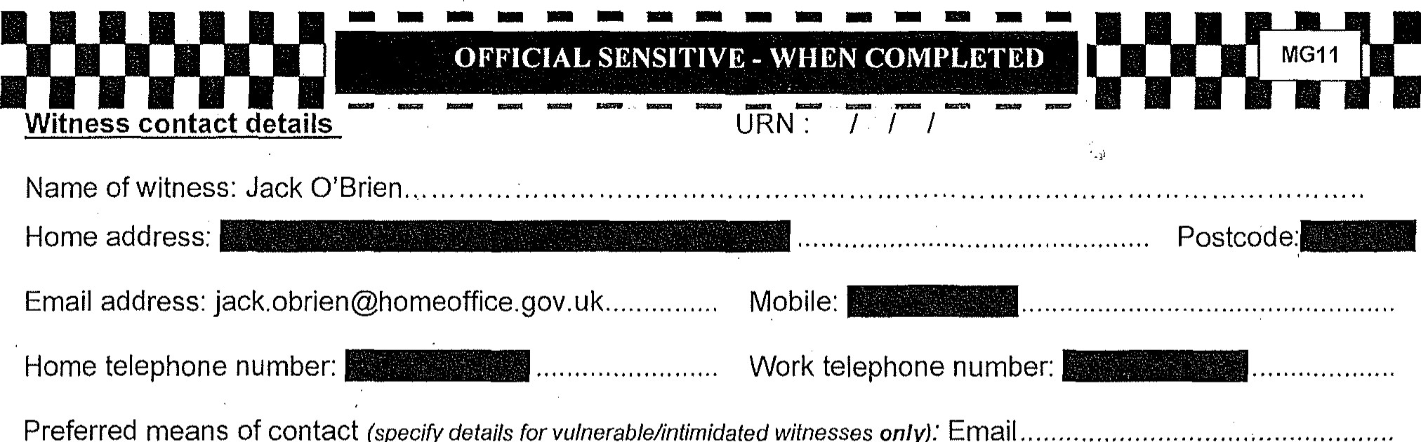
Home addres ^{s} :
means
Of
contact
(specify
details
vulnerable/intimidated
witnesses
only).'
Email
Home telephone number:
Gender: Male...
Former name: N/A
Ethnicity
Code
(16
+
1):
DATES OF WITNESS NON-AVAILABILITY:

Witness care
- Is the witness willing to attend court? Yes No [3 If 'No', include reason(s) on form MG6.
- What can be done to ensure attendance?
- Does the witness require a Special Measures Assessment as a vulnerable or intimidated witness? (youth under 18; witness with mental disorder, learning or physical disability; or witness in fear of giving evidence or witness is the complainant in a sexual offence case)
Yes C] No [3 If 'Yes', submit MG2 with file in anticipated not guilty, contested or indictable only cases.
- Does the witness have any particular needs? Yes [3 No [3 If 'Yes', what are they? (Disability, healthcare, childcare, transport, language difficulties, visually impaired, restricted mobility or other concerns?)
Witness Consent (for witness completion)
- The Victim Personal Statement scheme (victims only) has been explained to me: Yes No C]
- I have been given the Victim Personal Statement leaflet Yes
- I have been given the leaflet "Giving a witness statement to the Home Office.. Yes No C]
- I consent to police having access to my medical record(s) in relation to this Yes [3 No matter (obtained in accordance with local practice)
- I consent to my medical record in relation to this matter being disclosed to the Yes No defence:
- I consent to the statement being disclosed for the purposes of civil proceedings Yes C] No C] if applicable, e.g. child care proceedings, CICA g) Child witness cases only. I have had the provision regarding reporting
Yes [3 restrictions explained to me.
I would like the CPS to apply for reporting restrictions on my behalf. Yes No N/A I understand that the information recorded above will be passed on to the Witness Sewice, which offers help and support to witnesses pre-trial and at coutt.
Signature of witness:
Signature of parent/guardian/appropriate adult: PRINT NAME: ......
Address and telephone nurnber if different from above: .
Statement taken by (print name):
.
Time and place statement taken:
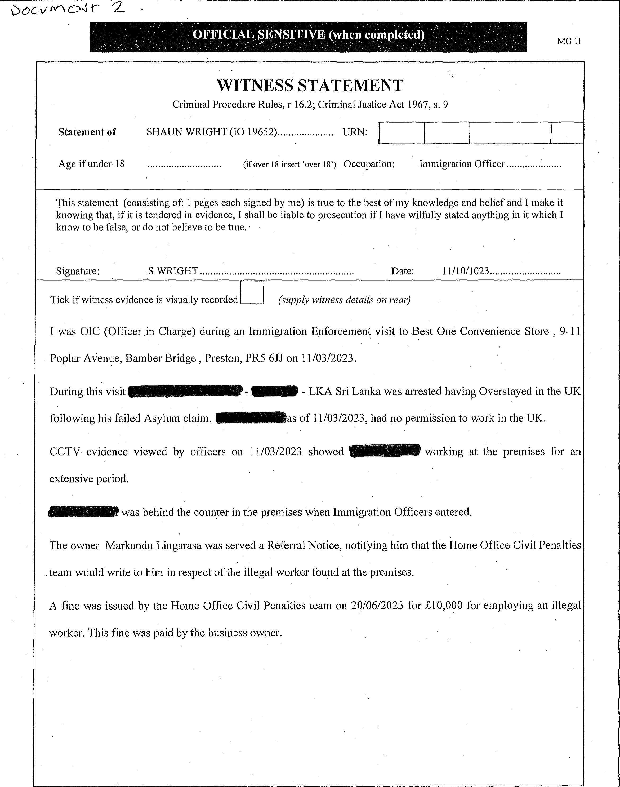
Signature: Signature witnessed by:
1 0/2017 MG I l

